There is some multi row data each verb wise in 3 segements.
One for reference forms area – full 10 lakaar verb forms
One for kridant area for – example vibhakti declinations of kridant forms
Two for Meaning area – upsargayukta dhaatu meaning, and dhaatu usage text
These should be accessible through tabs in these areas (suitably located) in the dhaatu pages. So that these open only if we click the tab and back button returns to the page.

- We have approx. 131 commonly used dhatu with complete 10 lakaar data. If this can be made available. It is approx.. 651 cells in 31 rows and 21 columns. Can we provide it in pages form with only the same dhaatu data accessed by a tab in the same dhaatu page. See whole lakar data example.xlsx
If we place a tab in or adjacent to reference forms. This tab is active only when there is data for it. On clicking these lakaar data pages open and back button takes us back to the original page.
Another tab takes us to dhatu usage pages.

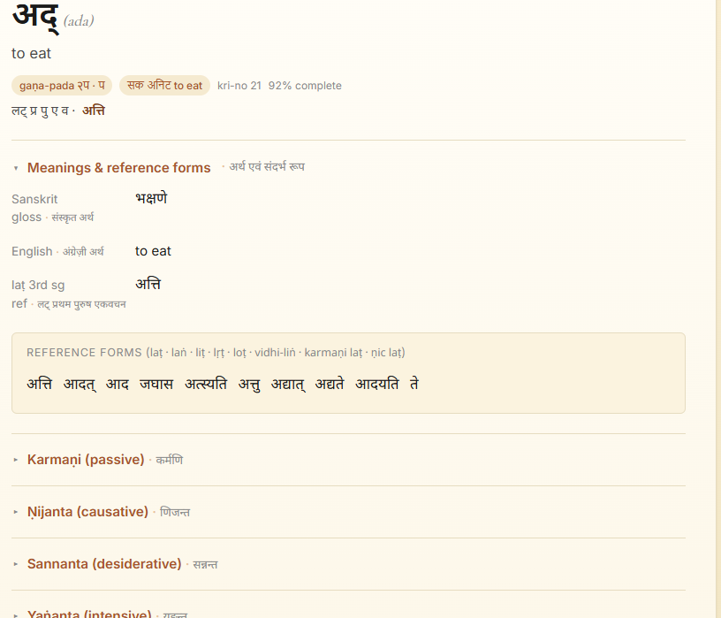

- Kridant words in text under review are in different vibhakti and vachan (and not always in prathamaa eka vachan like our data). We can provide kRidant declination examples from a tab next to each kridant, for example शतृ. The examples include both shuddha and nijanta.
See Kridant declination example.xlsx
This tab accesses the kridant declination example in पु स्त्री नपु for each kridant except avyaya kridant. Approx. 20rows 20columns per variation and such 9-10 separate data clusters (because some are common for more than 1). Both shuddha and nijanta is covered in this. Preferably the tab should access individual kridant cluster given kridant.

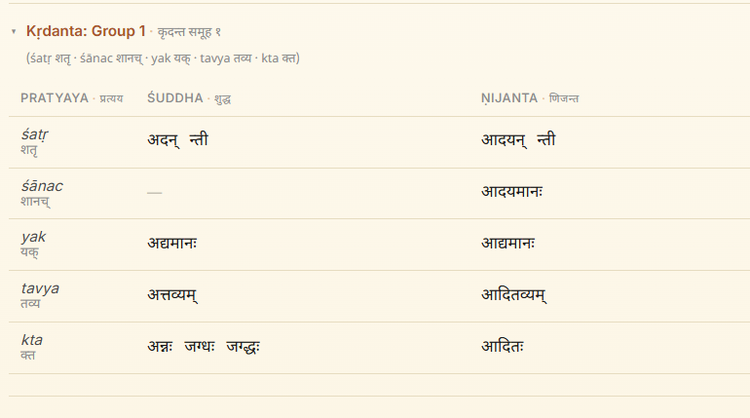

- Dhaatu meaning enhances or decreases or altogether changes with upsarga. We have common dhaatu with upasarga meaning and pada excel file. Not all upsarga are commonly used. So depending on the dhaatu we have 5-40 rows each for select verbs. Can a tab in sanskrit/english meaning area access relevant rows from the excel file and display.
- Verb usage module
We have some excel and word data showing lakaar and kridant forms used in as sentences and their anvaya and meaning. If this can be provided verb wise.
- Other modules
- Noun declination tables. Approx. 70 variations, each a minimum of 30-50 cell data. Usually categorized as अकारान्त पु , नपु or ईकारन्त or त् कारान्त or स् कारान्त् etc.
- Vyaakaran notes - under several headings 2-5 page word file data each.
- Other ambitious plans
- Sandhi vigraha module
Happy computing!

